Trader Interface Testing (ORACLE APEX)

Table of Content

1. Sign In

1. Sign in with empty username and password
2. Sign in with invalid password
3. Sign in with correct credentials

2. Products

1. View Products Details
2. View Product Discount

3. Dashboard

1. View Dashboard

4. Report

1. View Daily Report
2. View Weekly Finances
3. View Monthly Sales

5. Reviews

1. View Reviews and Ratings

6. Access

1. View Dashboard / Reports of other traders
2. View Dashboard of Admin

7. Logout

1. Logout of the trader from dashboard page

# Sign In

1. Trader sign in with empty username and password

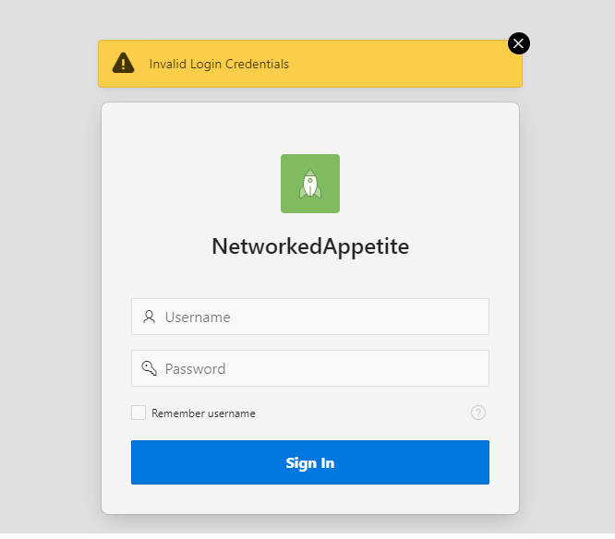

If trader tries to log in with empty username and password then an error message is displayed “Invalid Login Credentials”.

1. Sign In With Invalid Password



If trader tries to log in with wrong password then an error message is displayed ’Invalid Login Credentials’

1. Trader login with valid credentials(logged in with one of the trader account)

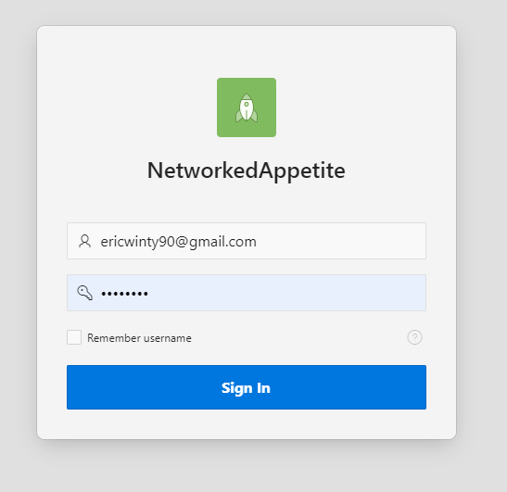

If trader log in with valid credentials then trader gains access to the Trader homepage. The homepage shows detail of the trader.

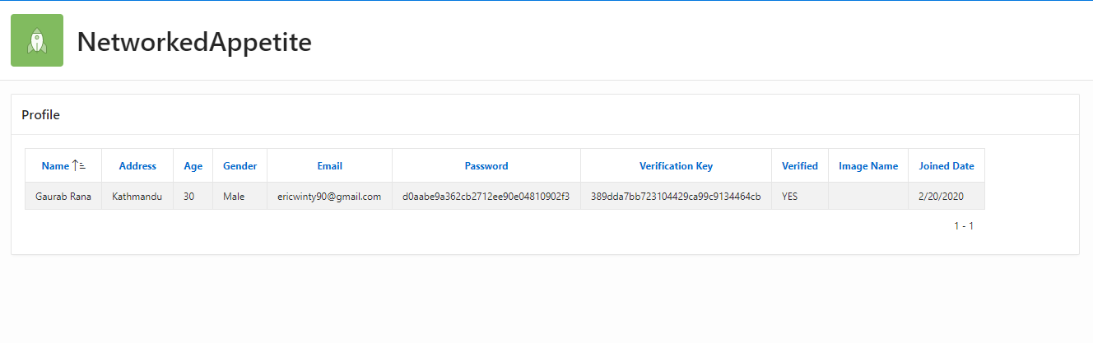

# Products

1. View Products Details

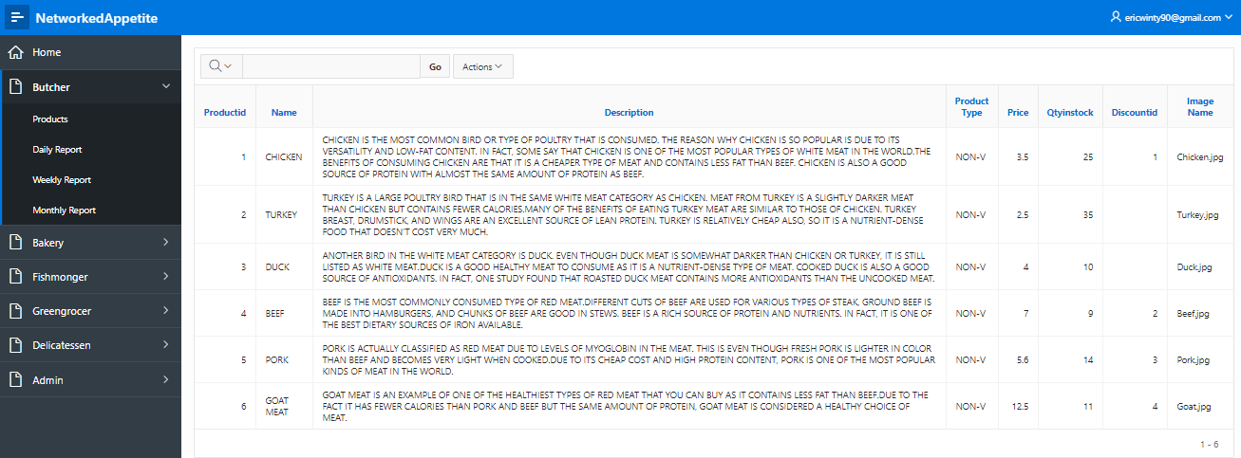

Trader can view details of each of their product.

1. View Product Discount

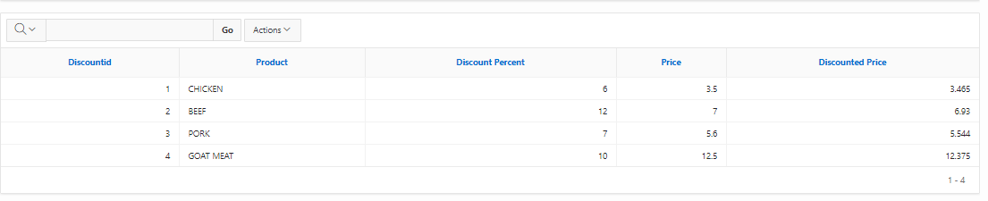

Trader can see what products they have given discount and price after discount.

# DASHBOARD

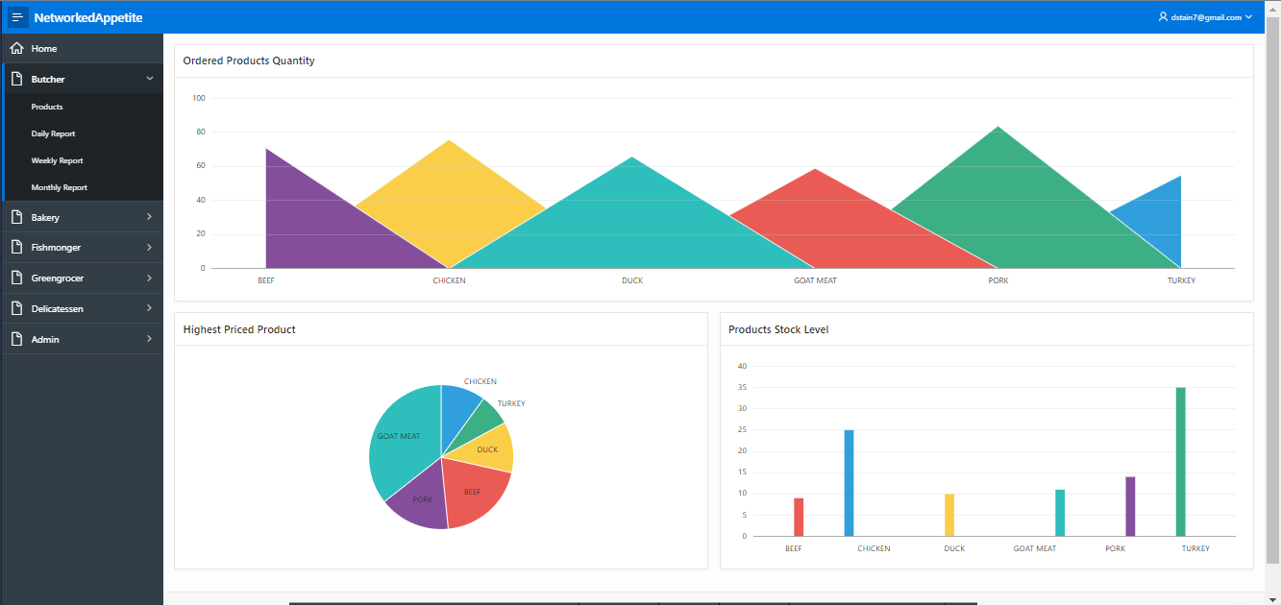

Trader can view their overall dashboard. The first chart shows the most ordered product of the trader. Pie Chart shows Highest Priced Product and bar graph shows Product Stock Level.

# REPORTS

1. Daily Order Report

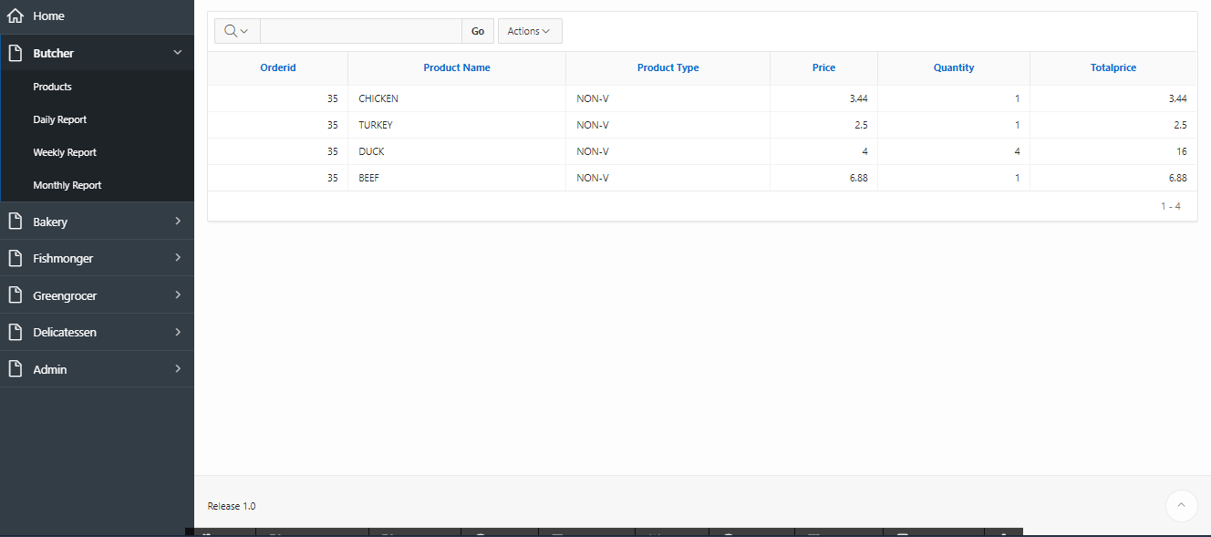

Trader can view their daily order reports.

1. View Weekly Finances

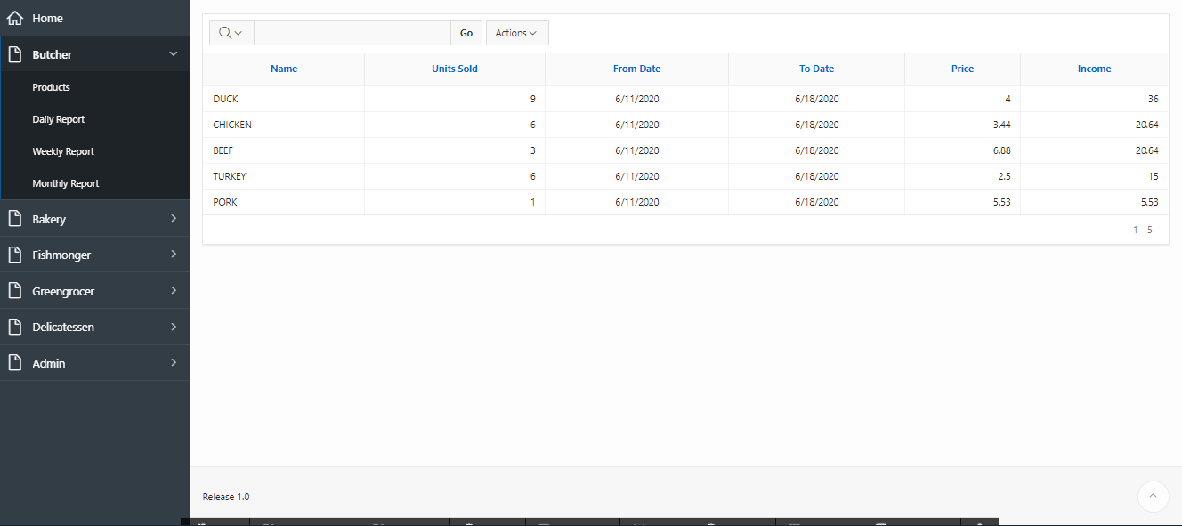

Trader can view their weekly finance report.

1. View Monthly Sales

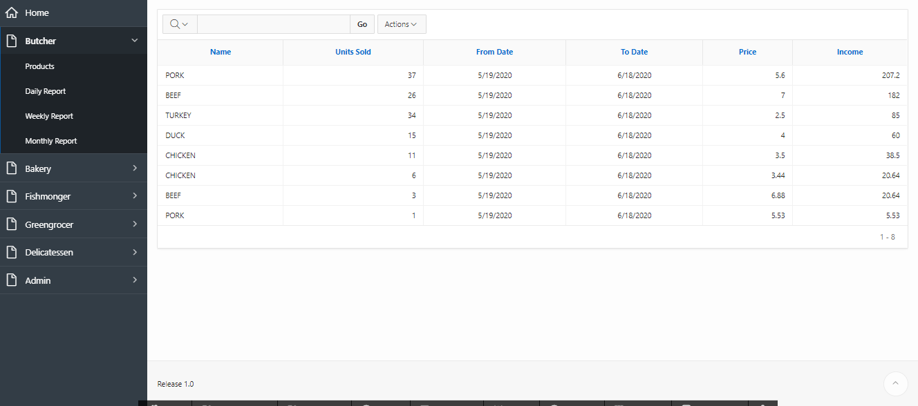

Traders can view their monthly sales report.

# Reviews

1. View Reviews And Rating Given By Customer

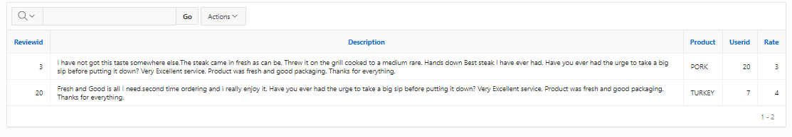

Traders can view the reviews and ratings given to their products.

# ACCESS

1. View Dashboard / Reports Of Other Traders

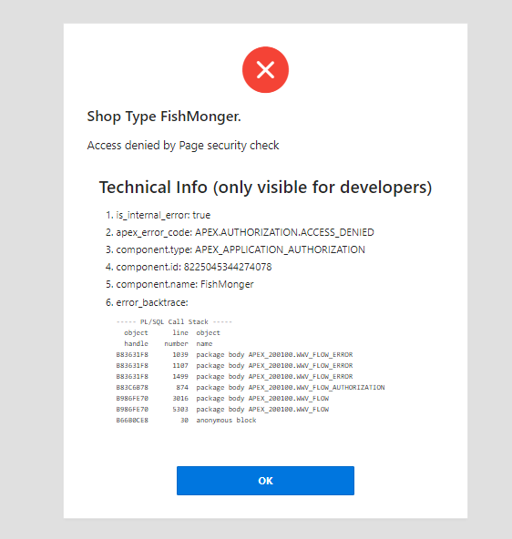

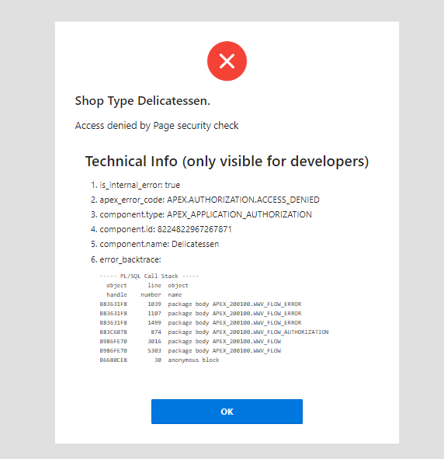

Traders are not given access to reports of other traders. If any trader tries to access those pages, they will be blocked along with the error message. Here we have tested trader butcher trying to access page of fishmonger and delicatessen.

1. View Admin Dashboard

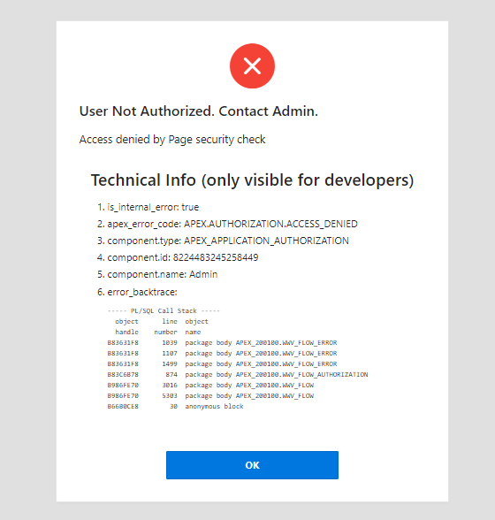

Traders are not allowed to access admin dashboard either. Trying to access will give error and access is denied as shown in picture above. Here we have tested butcher trader trying to access admin dashboard.

# Logout

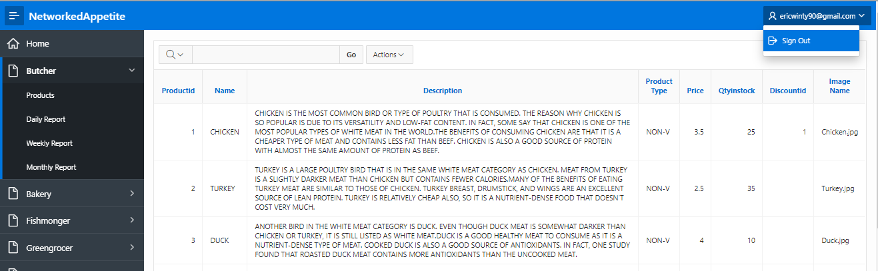

Traders can logout from the page using Sign Out button at the top right side of the page.